## **Objectives**

* Explain how to test void method

In this hands-on lab, you will learn how to:

* Create unit test project that tests a void method.

## **Prerequisites**

The following is required to complete this hands-on lab:

* Visual Studio 2019 or above Community Edition
* NUnit
* NUnit3TestAdapter

## **Notes**

Estimated time to complete this lab: **30 minutes.**

Create a Class Library project and add the following code into it.

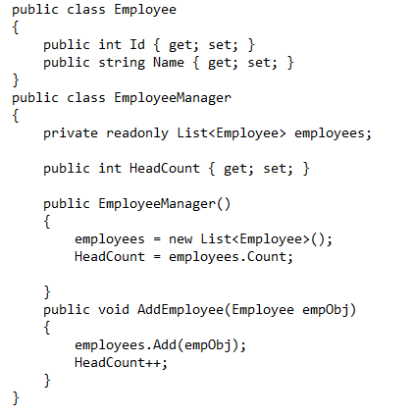

Write unit test case for the **AddEmployee()** method of **EmployeeManager** class that returns void.

Assert on the following.

* Before adding a new employee the HeadCount property should be 0
* After adding an employee the HeadCount property value should be 1

**Constraints:**

* *Enforce the Single Assertion Rule*
* *Use Assert.That()*

**Steps to perform**

1. Create a Class Library project in the same solution which is provided and name it as suggested.
2. Rename the class file name (<SUT>Tests.cs).
3. Add the assembly reference of the source project to the test project.
4. Additionally add the reference of both NUnit and NUnit3TestAdapter in the test project using NuGet Package Manager (NPM).
5. Write the suggested test methods.
6. Run your tests.
7. Break the test by modifying the source project functionality.
8. Rerun the test.
9. Observe the test result.